
Silvano Monasterios
& the 4th World Ensemble

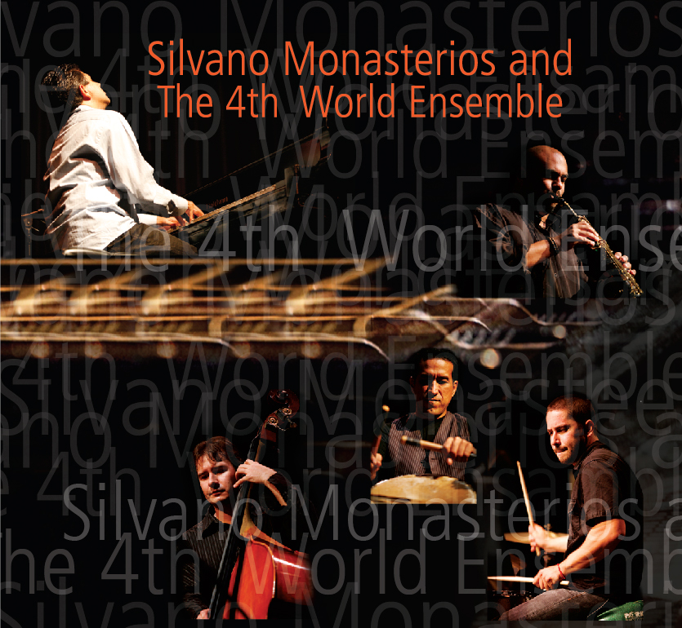`

Voted "Best Jazz Musician in Miami (2009)" by the Miami New Times, pianist-composer Silvano Monasterios hails from Caracas, Venezuela. Silvano has performed with a number of important artists including Ira Sullivan, Terumasa Hino & the World Jazz All-Stars, Othello Molineaux, Dave Liebman, Melton Mustafa, Marc Johnson, Donald Byrd, Alan Harris, Paquito D’Rivera, Arturo Sandoval, Nathen Page, Randy Brecker, Sammy Figueroa, Paul Wertico, Mark Egan, Shakira, David Lee Roth, and Nestor Torres.

In 1998, Silvano was voted “New Artist of the Year” at the Hennessy Cognac Jazz Search in New York City. 1998 also marked the release of his first CD, Roads Not Taken, which received outstanding reviews in the U.S. and Latin America. In 2006, his new recording, Fostered, was released. Fostered features all original compositions, including the award-winning “Avila”.

Silvano composed, performed & co-produced two songs, including the title track, of the 2008 GRAMMY-nominated album, "The Magician", by Sammy Figueroa & His Latin Jazz Explosion. This wonderful CD was nominated as "Best Latin Jazz Album of the Year".

The Fourth World Ensemble, emerging in 2007 from Monasterios' desire to experiment with the fusion of Latin Rhythms, World Music and Pure Jazz, features Monasterios on piano, accompanied by percussion, drums, bass and saxophone. The ensemble performs all original music composed and arranged by Silvano. This year saw the release of their new CD, Unconditional, on Savant Records. Exhibiting an insatiable appetite for challenge and change, Silvano has recorded eight new and imaginative compositions. While this latest work is likely destined to be classified as “Latin Jazz” with its assortment of indigenous percussion instruments and rhythms, it is totally devoid of the Latin clichés often encountered in pseudo-Latin jazz. Instead, it showcases an artist with a complete understanding of his complex Venezuelan roots, who is aware of the Austro-Germanic-European compositional heritage and who, at the same time, is steeped in the great American jazz tradition.

What the critics say:

“Local jazz fans are lucky to have a star such as Silvano Monasterios playing in our midst. He is a bona fide piano prodigy” Miami New Times

"Best Jazz Musician in Miami (2009)" Miami New Times

“The Venezuelan –born pianist arguably is South Florida’s most accomplished composer.” Dr. Ron Weber, South Florida Jazz Organization

“From the shortest phrase to the longest, though the language of jazz is obvious, his own sound and style has, and will ever be refreshing to me.” Jeff Laibson

“In addition to his teacher, Vince Maggio, Monasterios has absorbed the influence of a long list of piano giants, most noticeably Chick Corea, Herbie Hancock and Bill Evans.” Ed Enright, Downbeat Magazine

“Best Jazz Instrumental Soloist Award” DownBeat 28th Annual Student Music Awards 2005

“New Artist of the Year” Hennessy Cognac Jazz Search NY 1998

“Best Soloist Award” Miami Jazz Festival 1989

BOOKING: KCC PRODUCTIONS
+1-305-332-2623
www.kccproductions.com kcc_productions@yahoo.com
Villafranca Dr Michael White

BOOKING: KCC PRODUCTIONS
+1-305-332-2623
www.kccproductions.com kcc_productions@yahoo.com

